**Optimal placement of Micro-Mobility Transport Services in Austin**

Kalyan Kumar Alisetty and Goutam Chakraborty

Oklahoma State University, Stillwater, OK, USA

**Abstract:**

An increase in vehicle carbon footprint is a global concern that the countries are seeking to address consciously. Governments are proactive in dealing with this issue by introducing shared mobility devices in cities. Shared mobility devices are transport systems that allow citizens to pool or share their mode of commute. Shared Vehicle services refer to two-wheeler motorcycles, mopeds, small electric vehicles that require a license to drive. Micro mobility devices are a component of the shared mobility systems that majorly involve scooters, skateboards, bicycles or any other compact devices without a license plate. To improve the Air Quality Index (AQI) and reduce vehicular traffic city governments are implementing the shared mobility systems in their downtowns. This paper is a case study that evaluates the data corresponding to the trips completed by the shared mobility devices in Austin, Texas for a period. We have analysed how does the usage of micro-mobility devices vary based on climatic conditions and their impact on environment is assessed.

**Introduction:**

Over the past decade, bicycle-sharing systems have been growing in number and popularity in cities across the world. Bicycle-sharing systems allow users to rent bicycles for short trips, typically 30 minutes or less. With the latest technologies, it is easy for a user of the system to access a dock within the system to unlock or return bicycles. These technologies also provide a wealth of data that can be used to explore how these bike-sharing systems are used. But, sometimes it’s hard to find a vehicle out of the house. So, our paper addressing the issue of users by helping the owners to know usage of micro-mobility devices at different times in a day. We have also assessed the effect of this usage on the environmental conditions. These findings will benefit the city government of Austin and also micro-mobility owners which can be extended to other downtowns.

**Data Description and cleaning:**

The trip information was pooled from the Austin government data website and climate data pertaining to an hour was scraped from I-weather. The Air quality data was collected from EPA website and the holidays list was collected from the Kaggle. We have aggregated the trip dataset to get the count of trips for an hour only for some important locations. The Trip counts dataset was merged with the climate and holidays list to get the final dataset. The below figure gives a glance of our final dataset.

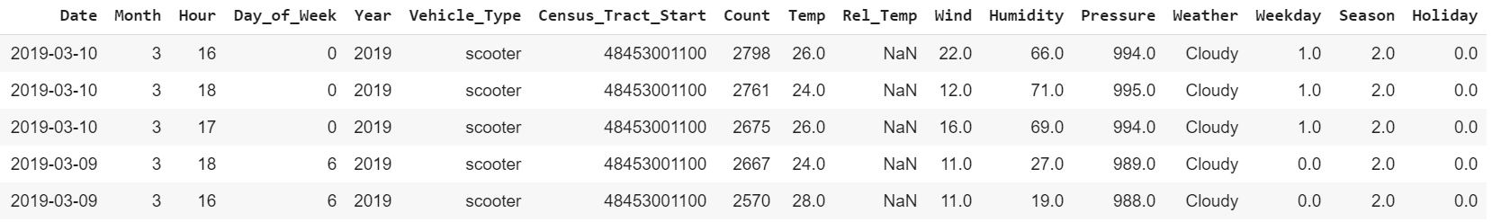

The data consists of 6 numerical variables with count being the target, 11 nominal variables. The variables such as Weekday (0 for weekends), Season, Hour, Year, Month, Holiday (1 for National holiday), Day of Week are derived from the date column. The total area of Austin is divided in the equally spaced hexagonal cubes and given an ID which is stored in the column Census Tract Start.

**Exploratory analysis:**

As the location fields are encoded, the below graph shows the average number of trips taken from each encoded location for an hour and the geographical plot of area from which has the highest average. The encoded location can be found at Census Reporter website[1]. The area with the highest average is the downtown of Austin. Due to high gathering of people in the downtowns its obvious that more amounts of trips originate in downtown.

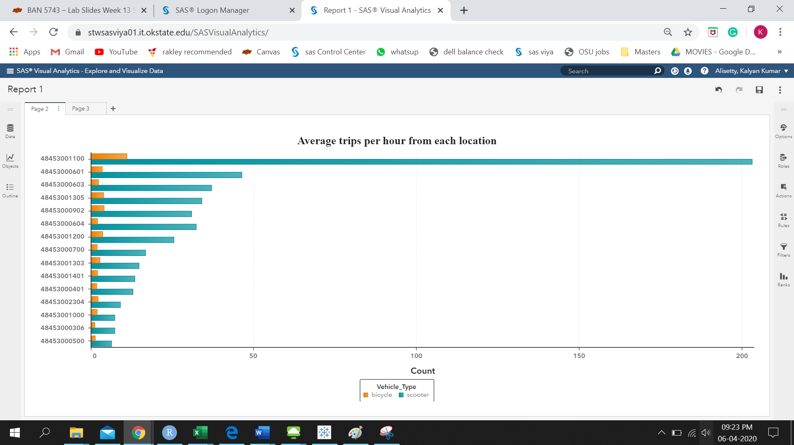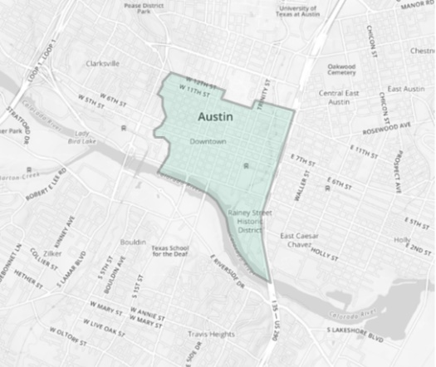

The below graph shows the average number of trips taken by the people of Austin in each hour. The average number of trips is high during the evening as most of the people return home from office using micro-mobility devices and also as the vehicle traffic is more during the evening, users try to use these devices for short distance traversing.

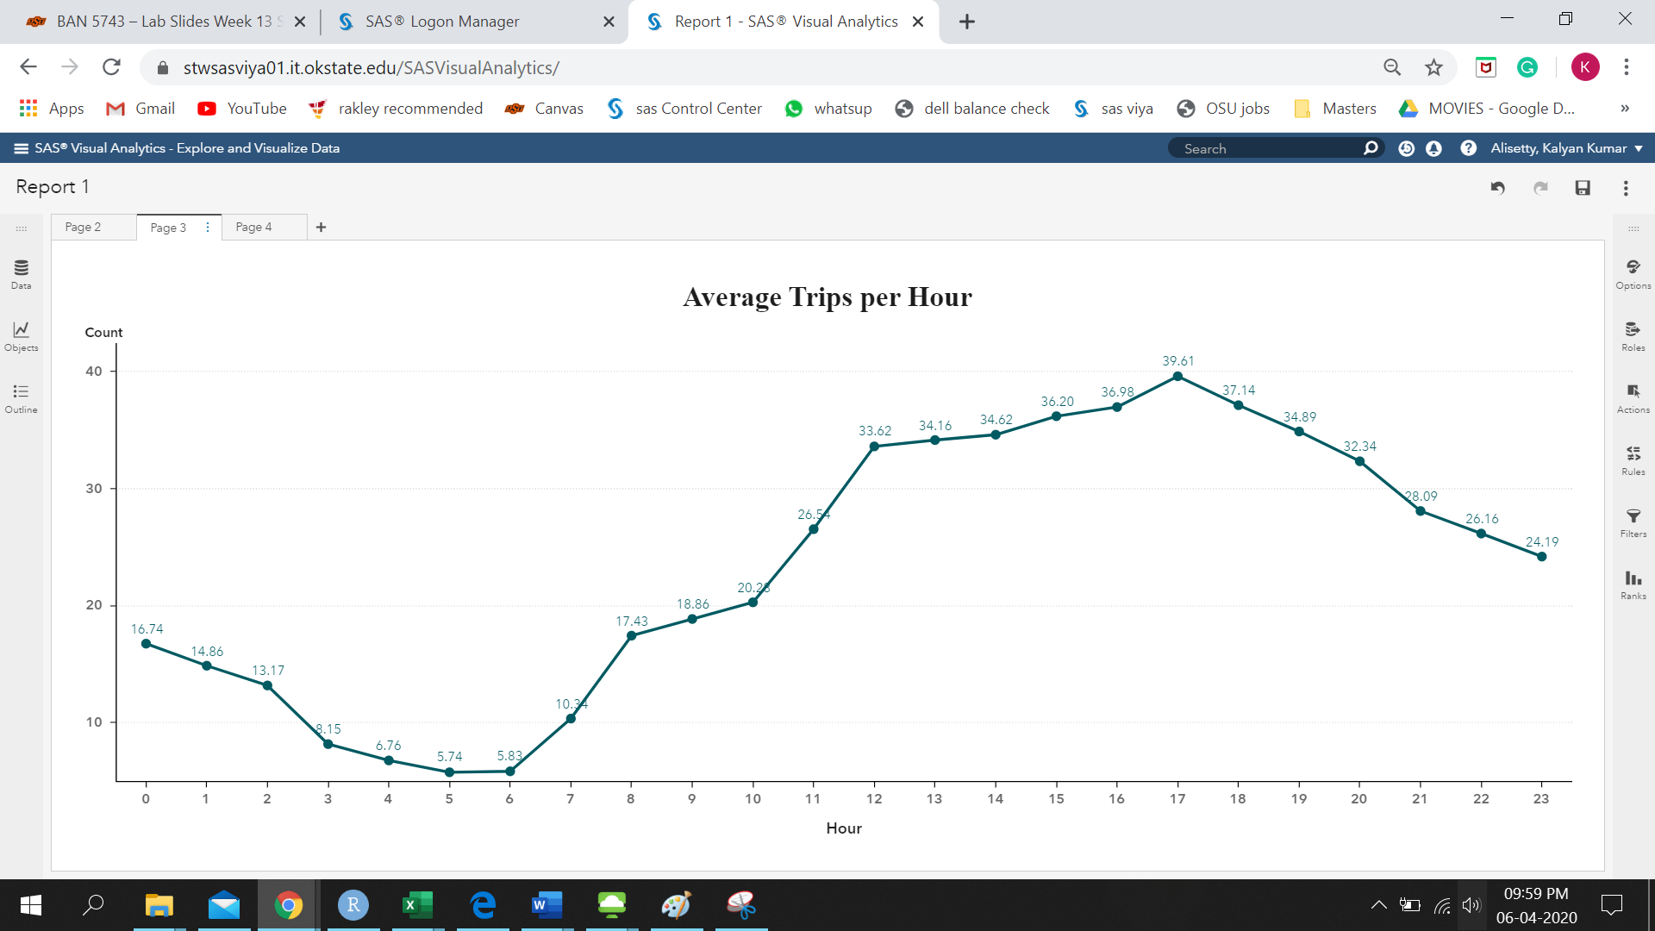

The below graph visualizes the average number of trips taken by the user on each day of a week. The ‘0’ on the x-axis signifies ‘Sunday’ and so on. The graph indicates an increase in the number of the trips in the weekend as most of the people stay at home on weekends and would like to travel short distances for partying or meeting friends using micro-mobility devices.

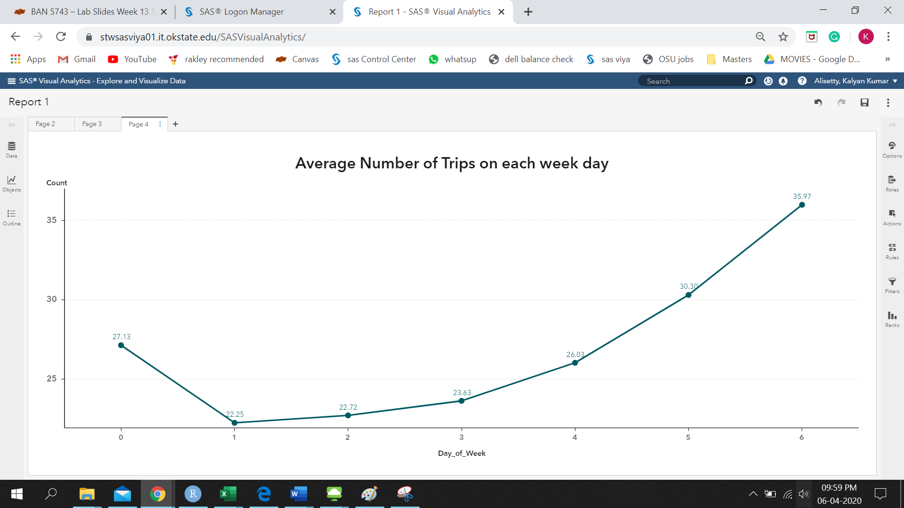

The Average number of trips in an hour depends on the climatic conditions which is evident from the graph below. The number of scooter trips are generally less during snowy day and high on a clear day. But, the number of bicycle trips are almost equal independent of the weather conditions.

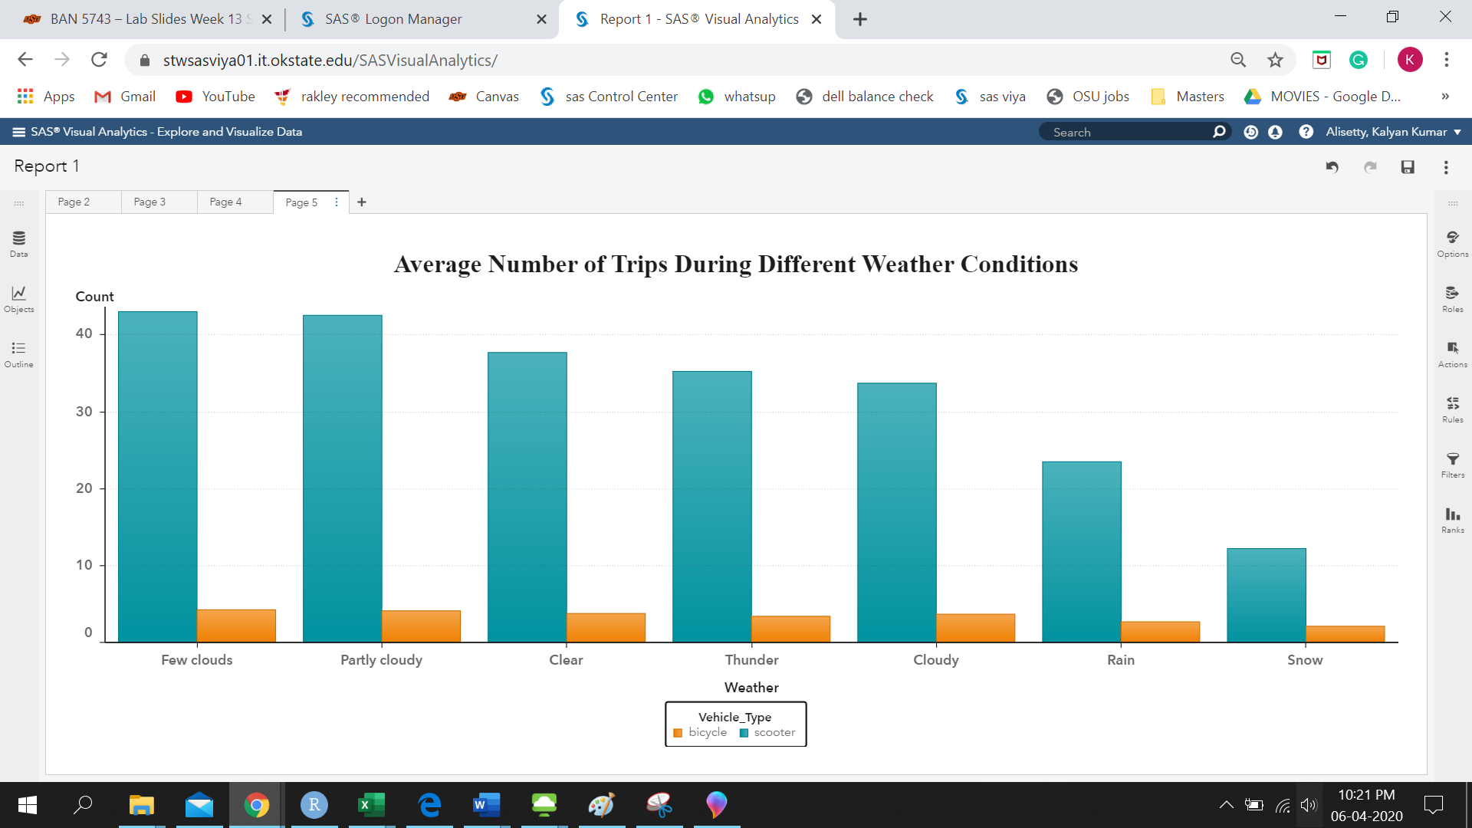

**Model Results:**

The model has been built in the SAS Enterprise Miner. Before building a model, the data needs to be cleaned and transformed to normalize it. So, We have initially imputed the variables using the tree imputation and Transformed the imputed wind using the square root function to normalize it.

Using the cleaned, we have selected count as the target variables and remaining variables except Rel_Temp, Date and Year as independent variables and built different models such as decision tree, neural net, neural net with variable selection, regression. Out of the different models build Neural Net is chosen as champion model as it has the lowest test validation square error. As Neural Net is a black box model we have connected a decision tree to the predicted values to explain the model easily in the form if..then..

The below figure shows the SAS Enterprise Miner diagram of the current project:

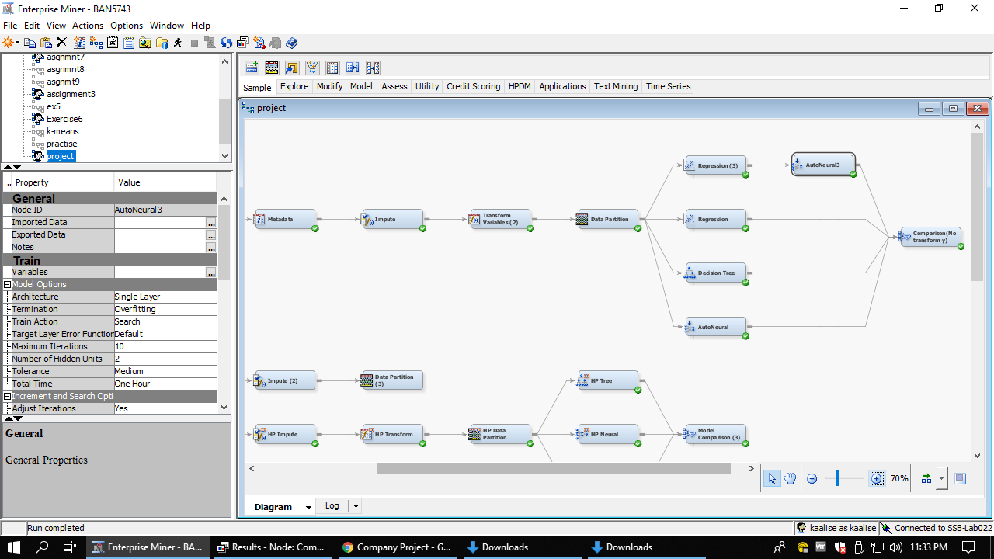

The below figure shown the comparison of different models.

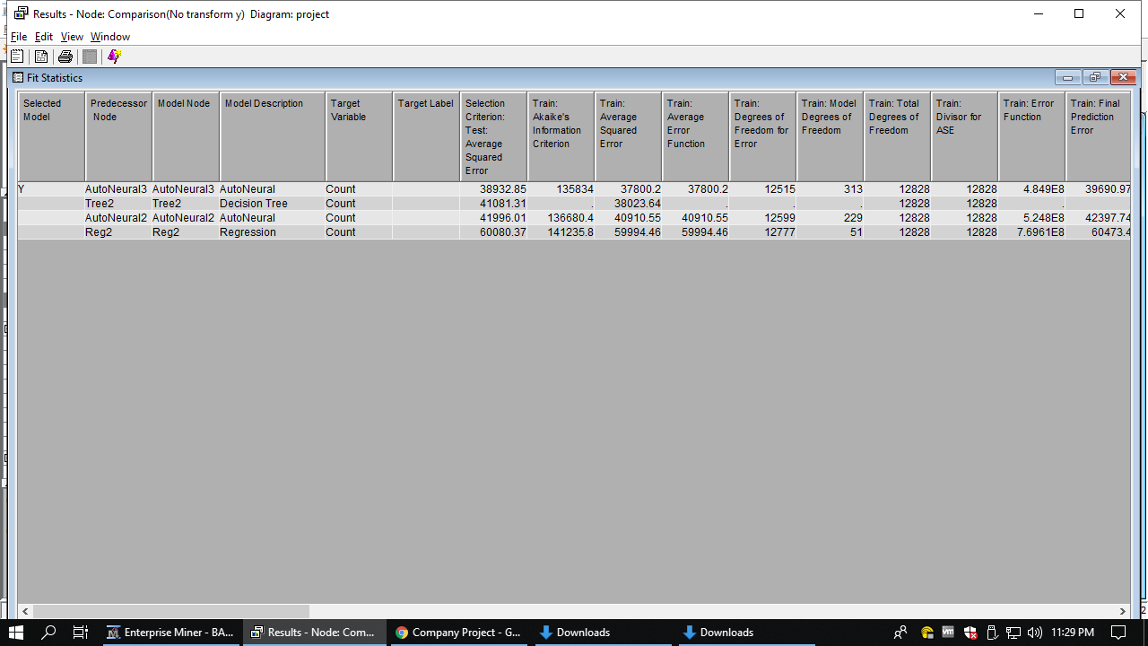

The below figure shows the importance of different variables used in building the model.

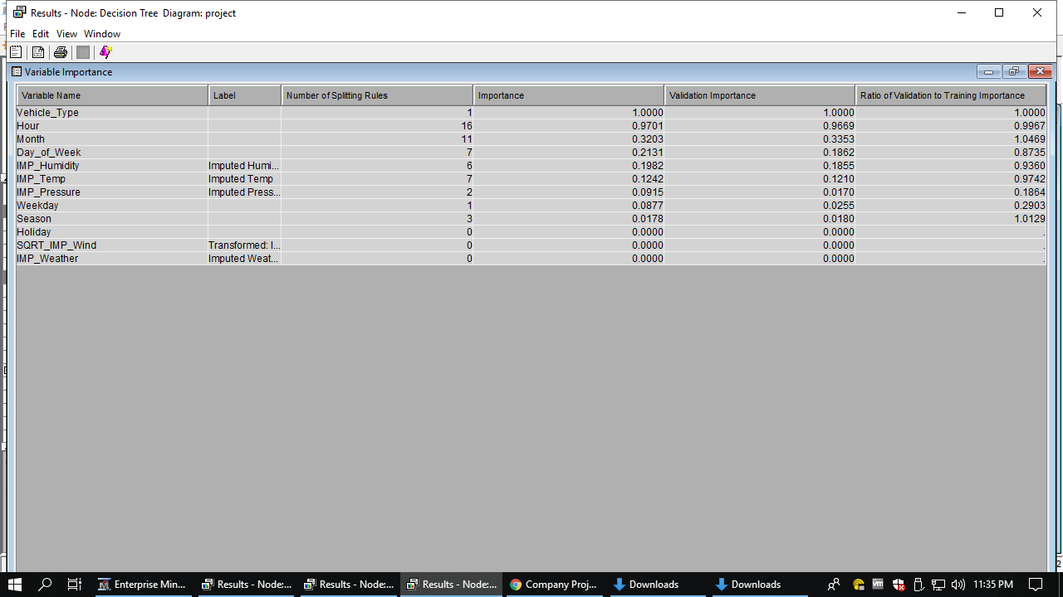

So, from the results of the model we can say that the scooters are more used by the people. The second finding from the model is that the people in the evening are using most of the micro-mobility services. The third finding is that riders use less number of devices during summer and also during the snow (during December). Most of the devices are being used during the weekends than the weekdays. When the humidity is higher people tend to use less number of devices and also when the temperature is between 12 and 36 degrees, users tend to use more number of devices.

**Conclusion:**

From the above analysis and models, few insights were derived. Weather has some effect on the demand. Demand tend to decrease for higher temperatures and higher humidity conditions. The demand of micro-mobility devices is highest on Saturdays followed by Fridays and Sundays, same as the pattern in Downtown (majority of the rides are from Downtown). The peak time for taxi rides is at 18:00 hours and the least is during 6:00 hours. The Clear climatic conditions are suitable for the riders while snow weather is having the smaller number of trips recorded. **The forecasting is a good fit for all the boroughs except State Island since it has a very low number of rides.** The hourly prediction of rides at the boroughs can really help the micro-mobility devices company to plan early and optimally utilize model predictions to meet the demand of their riders.

This project had the limitations of lack of multivariate time series modeling. Also since yellow taxis doesn’t have any surges depending on time of the day, fare has been excluded from the analysis. Hourly weather data with weather event of the day like rain, sunny etc. was not obtained for the project.

**Future Scope:**

We need to collect the data of the traffic inorder to know the correlation between the demand and traffic. We can also perform time series analysis to incorporate timely data and get the forecasts for future data

**References:**

1. Census Reporter website to track the locations which are encoded in the dataset given <https://censusreporter.org/profiles/14000US48453001100-census-tract-11-travis-tx/>
2. Data set website

<https://data.austintexas.gov/Transportation-and-Mobility/Shared-Micromobility-Vehicle-Trips/7d8e-dm7r>

1. Climate data

<https://i-weather.com/>

**Contact Information:**

Your comments and questions are valued and encouraged.

Contact the authors at:

Name: Kalyan Kumar Alisetty

Enterprise: Oklahoma State University

Address: Department of MSBANDS, Oklahoma State University City, Stillwater, OK - 74074

Work Phone: (405)780-5102

E-mail: Kalyan_kumar.alisetty@okstate.edu

Name: Dr. Goutam Chakraborty

Enterprise: Oklahoma State University

Address: Department of Marketing, Oklahoma State University City, Stillwater, OK - 74074

Work Phone: (405)744-7644

E-mail: [goutam.chakraborty@okstate.edu](mailto:goutam.chakraborty@okstate.edu)

SAS and all other SAS Institute Inc. product or service names are registered trademarks or trademarks of SAS Institute Inc. in the USA and other countries. ® indicates USA registration. Other brand and product names are trademarks of their respective companies.